Architecture Document
Project: Distributed AI Software Development Platform (CM6453 Software Processes, Team 7) · Author: Nehir Tunç

1. Overview
A user enters a software requirement. A master agent splits it into subtasks with a local LLM, and sends tasks to worker agents. Each worker agent runs on its own computer and uses its own local model through Ollama (for example llama3 or qwen2.5-coder:1.5b). No cloud API key is needed. The master and the agents talk over HTTP and JSON inside a private Tailscale network, so their APIs are not reachable from the open internet.
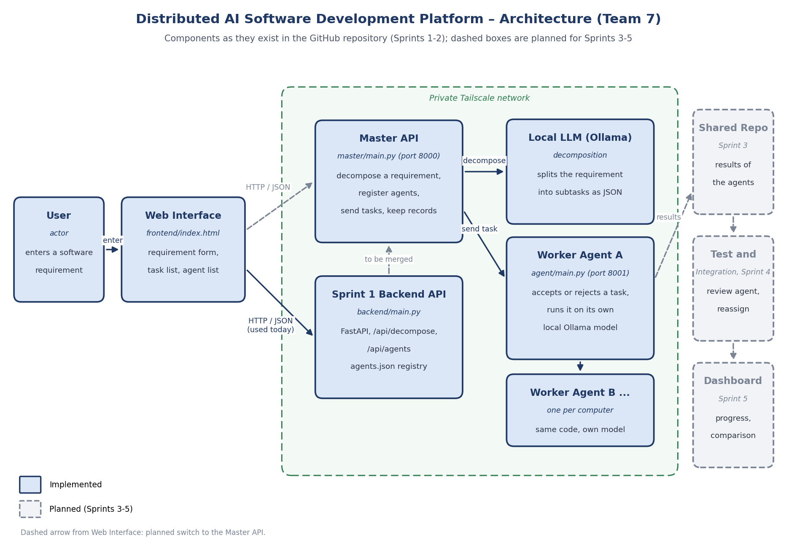
Architecture diagram

2. Components
Component | Location in the repository | What it does
Web interface | frontend/index.html | Requirement form, task list, agent list and agent registration form.
Sprint 1 backend API | backend/main.py, backend/master_agent.py, backend/agents.json | FastAPI app used by the web interface today: /api/decompose splits a requirement, /api/agents adds, lists and removes agents (stored in agents.json).
Master API | master/main.py, master/decompose.py | FastAPI app on port 8000: decomposes a requirement (/api/v1/requirements/decompose), registers agents, sends a task to a chosen agent and keeps the dispatch records (/api/v1/agents, /api/v1/agents/{id}/tasks, /api/v1/tasks).
Worker agent | agent/main.py | One per computer (port 8001 and up). Receives a task, accepts or rejects it (wrong agent, unsupported type, full queue), runs it on its own Ollama model and reports health and result.
Shared code | shared/schemas.py, shared/network.py | Message formats (the API contract) and binding to the Tailscale address.
Tests and CI | tests/, .github/workflows/ci.yml | pytest suite that runs on every push and pull request.
If the local model is not available, decomposition falls back to a fixed five-task breakdown, so the endpoint still works offline and in tests.

3. Main flow
- The user types a requirement in the web interface.
- The interface sends it to the backend (/api/decompose).
- A local LLM splits it into subtasks (id, title, category, description, dependencies).
- The interface shows the task list and the registered agents.
- The master registers a worker agent and sends it a task (POST /api/v1/agents/{id}/tasks).
- The agent answers at once with an acknowledgement (accepted or rejected, queue position) and runs the task in the background; its result is read with GET /agent/v1/tasks/{task_id}/result.
- (Sprint 3 to 5) Results are collected in a shared repository, tested, integrated and shown on a dashboard.

4. Data
Subtask: task_id, title, category (frontend, backend, database, testing, documentation, integration, requirements), description, dependencies.
Agent: agent_id, name or base_url, model, capability scores coding, reasoning, context (0 to 100).
Task message and acknowledgement: defined in shared/schemas.py and described in docs/api/task-dispatch-contract.md.

5. Design decisions
Decision | Reason
Local models with Ollama | Free, no API key, works on every member’s computer.
Tailscale network | Computers in different places can reach each other safely without opening the internet.
FastAPI | Small, fast to build, and gives a test page (Swagger, /docs) for the demo.
One agent service per computer | Matches the course idea: each computer has its own LLM and strengths.
Fallback decomposition | The master keeps working when the model is down.
Pydantic schemas shared by master and agents | The message format is the same in code and in the documentation.

